PRP – Implementation

Implementation Approach
The implementation of the Azure network environment follows a structured Hub-and-Spoke architecture. The goal is to create a scalable and segmented network foundation that supports multiple workloads while maintaining clear separation between environments.
The deployment is carried out in a controlled sequence to ensure consistency and avoid configuration conflicts. The implementation focuses on establishing core networking components such as virtual networks, subnets, and peering relationships.
Infrastructure is deployed using a combination of manual configuration and Infrastructure as Code (Bicep), ensuring repeatability and standardization across resources.

Network Design Overview
The environment consists of a Hub network and multiple Spoke networks, each with a dedicated purpose and address space.

Virtual Network (Hub Spoke) Setup
Hub Network
- Address space: 10.0.0.0/16
- Acts as the central connectivity layer in the architecture
- Provides shared connectivity services for all spoke networks
- Serves as the main routing and interconnection point within the environment

Identity VNet
- Address space: 10.10.0.0/16
- Purpose: Core identity and authentication services
Subnets:
- snet-identity-dc → 10.10.1.0/24 (Domain Controllers)
- snet-identity-mgmt → 10.10.2.0/24 (Management access)
- snet-identity-services → 10.10.3.0/24 (Identity services)
This network is isolated to ensure secure handling of authentication and directory-related services.
Automation VNet
- Address space: 10.50.0.0/16
- Purpose: an virtual network created for the use of Ahmed who created a service which deploys services using bicep templates automaticaly
Subnet:
- Automation-Subnet → 10.50.1.0/24

IoT VNet
- Address space: 10.40.0.0/16
- Purpose: For future scalability of running the barrier systems of the holiday parks in the cloud. This will nto be implemented but the vnet is here
Subnet:
- snet-iot-default → 10.40.1.0/24
This network is prepared for future IoT integrations and edge-connected systems.

Reservation VNet
- Adress space: 10.30.0.0/16
- Purpose: contain and isolate the front facing webapp and database used to host our reservsgion platform
Subnet:
- Snet-frontend – 10.30.1.0/24
- Snet-backend – 10.30.2.0/24
- Snet-private-endpoint-sql-database – 10.30.3.0/24

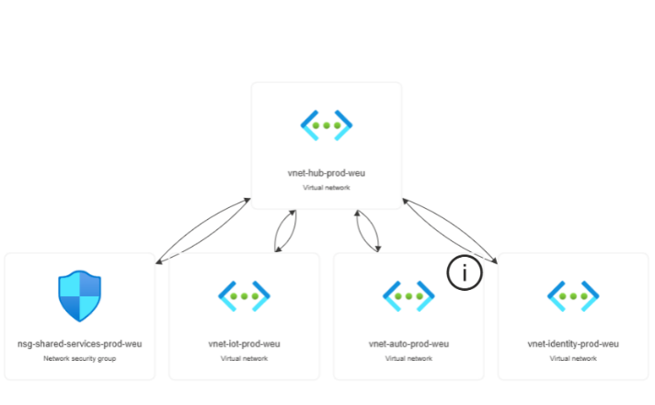
VNet Peering Design
All spoke virtual networks are connected to the Hub VNet using VNet Peering.
Peering configuration:
- Hub → Spoke communication enabled
- Spoke → Hub communication enabled
- Direct Spoke → Spoke communication is not allowed
This ensures that all inter-network traffic is controlled through the hub, enforcing centralization and segmentation of workloads.

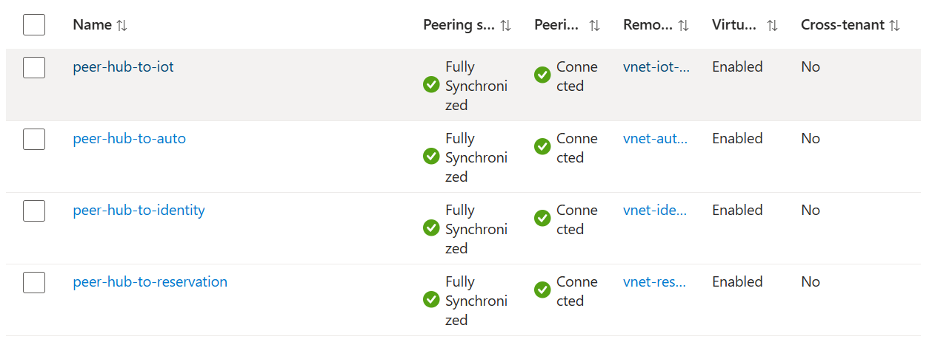
Peering
For all spokes the same peering setup is implemented this means that every spoke can send traffic to and from the hub but not directly to another spoke this ensures that all flowing traffic can be monitored using the centralized hub Vnet this ensures that is is easier and more secure

Peer-X-to-hub:
Allow vnet-X-prod-weu to access vnet-hub-prod-weu
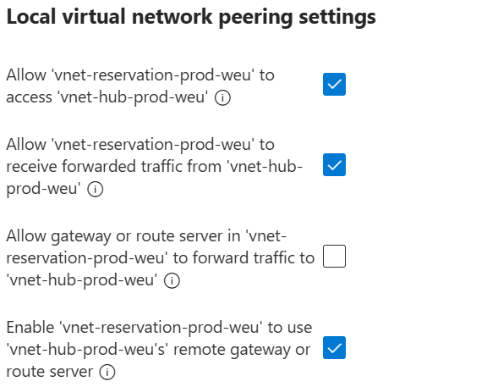
  - Allow, this is needed for the peer connection of data between the 2 networks
Allow vnet-X-prod-weu to receive forwarded traffic from vnet-hub-prod-weu
  - Allow ,this is important for data flow trough the hub
Enable vnet-iot-prod-weu to use vnet-hub-prod-weu's remote gateway
  - Allow this is what lets the spoke use the VPN gateway
Allow gateway or route server in vnet-X-prod-weu to forward trafficto vnet-hub-prod-weu
  - Disable, The spoke does not host the gateway

Peer-hub-to-X:
Allow vnet-hub-prod-weu to access vnet-X-prod-weu
  - Allow
Allow vnet-hub-prod-weu to receive forwarded traffic from vnet-X-prod-weu
  - Allow, Needed for routed traffic scenarios
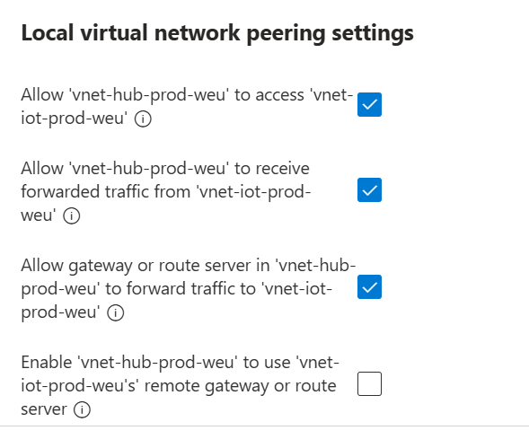
Allow gateway or route server in vnet-hub-prod-weu to forward traffic to vnet-X-prod-weu
  - Allow, exposes the hub VPN gateway to spokes
Enable vnet-hub-prod-weu to use vnet-X-prod-weu's remote gateway
  - Disable, hub should not use spoke gateways

NSG rules
To enforce subnet security within the Virtual network used for the reservation application: vnet-reservation-prod-weu, Network Security Groups (NSGs) are applied using a least-privilege, traffic-flow-based model. The design ensures that only explicitly required communication between tiers is allowed, while all other traffic is denied.
The network is segmented into three subnets:
- snet-frontend (10.30.1.0/24) – public facing
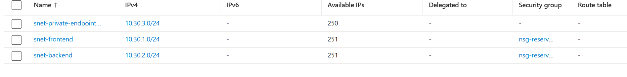
- snet-backend (10.30.2.0/24) – internal application and API layer
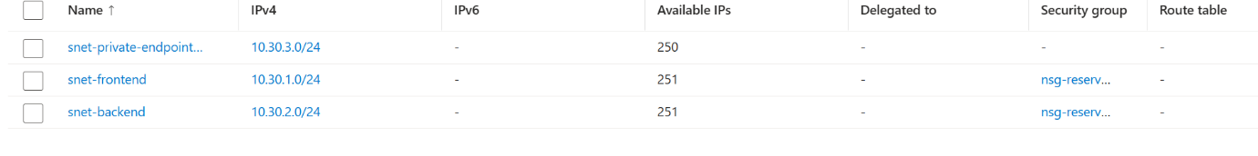
- snet-private-endpoint-db-sql (10.30.3.0/24) – private endpoint subnet for the used Azure SQL Database

Frontend Subnet NSG (nsg-reservation-prod-frontend)
The frontend subnet is designed to host the public-facing application layer. It is the only subnet exposed to the internet.
Inbound rules:
- Allow TCP 80 (HTTP) from Internet -> frontend subnet
- Allow TCP 443 (HTTPS) from Internet -> frontend subnet
- Deny TCP 22 (SSH) from Internet -> frontend subnet
Outbound rules:
- Allow traffic to Virtual Network (used for internal communication if needed)
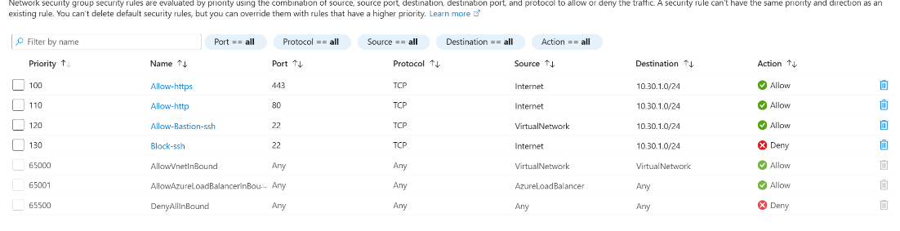
- Allow traffic to Internet (required for external service dependencies such as Azure services and APIs)

Backend Subnet NSG (nsg-reservation-prod-backend)
The backend subnet hosts internal services such as APIs and business logic. It is not directly accessible from the internet.
Inbound rules:
- Allow TCP traffic from frontend subnet (10.30.1.0/24) to backend subnet (10.30.2.0/24) on required application ports
- Deny all inbound traffic from the Internet
Outbound rules:
- Allow traffic to Virtual Network for internal service communication
- Allow outbound traffic only when required (e.g., to private endpoints such as the database subnet)

Private Endpoint Subnet (snet-private-endpoint-db-sql)
This subnet is dedicated exclusively to Azure Private Link resources used for secure connectivity to Azure SQL Database. It does not host compute resources.
Because communication is handled through Private Link and platform-managed networking, minimal NSG configuration is required.
Configuration approach:
- No direct inbound access from Internet
- No application-level access rules required
- Optional: allow Virtual Network traffic for platform communication requirements
Security is primarily enforced through:
- Private Endpoint (Azure Private Link)
- Disabled public network access on Azure SQL Database
- Azure Entra ID authentication and managed identity access

Logs
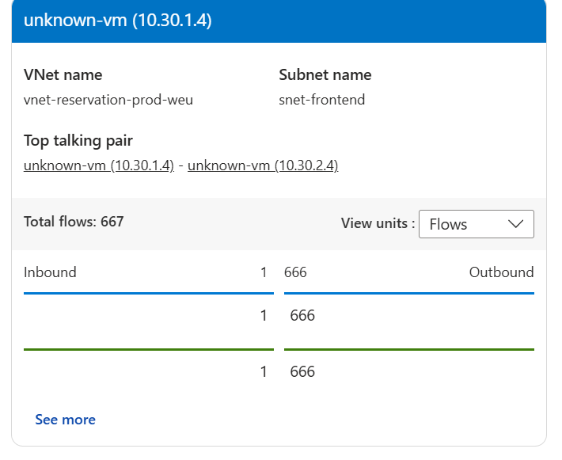
Virtual Network Flow Logs and Traffic Analytics were configured for the Reservation VNet.
Vnet Flow Logs were enabled at subnet level and forwarded to a Log Analytics Workspace. Traffic Analytics was configured to process and visualize the collected flow data.
The configuration is active and successfully collecting logs from the Reservation VNet. But because we are in an early-stage deployment, traffic volume is limited as only partial infrastructure components are deployed for my testing.
The logging pipeline is operational and ready to capture and analyze network traffic once full application workloads are active.

For now i tested the logging using 2 testVms which i connected to using Bastion they were one the front and backen subnet for testing the traffic flow logs

IaC
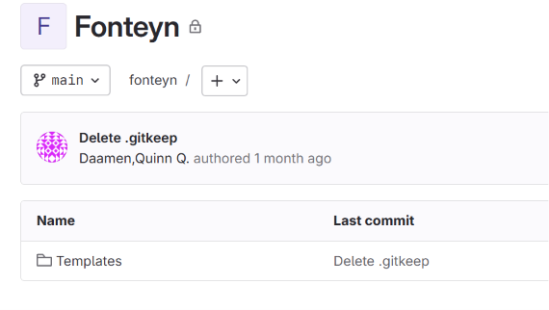
I used Bicep templates for the deployment of the Azure network environment. This includes resources like virtual networks, subnets, NSGs, VNet peering and monitoring components such as flow logs.
All Bicep files are stored in a GitLab repository so team members can access and reuse them if needed.
This ensures that deployments are consistent and reduces manual configuration mistakes. It also makes it faster to deploy the full infrastructure because everything is predefined in code instead of being configured manually.

Testing and Validation:
Test Cases
Test 1: Frontend - Backend Communication
- Expected: allowed only on defined ports
- Result: communication follows NSG rules correctly
Test 2: Backend - Internet Access
- Expected: restricted or controlled
- Result: traffic is blocked unless explicitly allowed
Test 3: Cross-Subnet Unauthorized Access
- Expected: denied and logged in NSG flow logs
- Result: traffic is blocked and recorded in logs

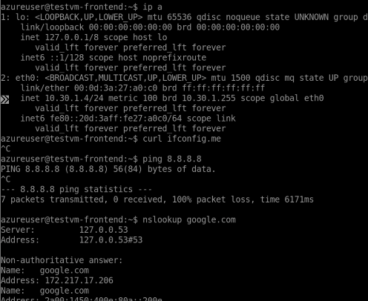
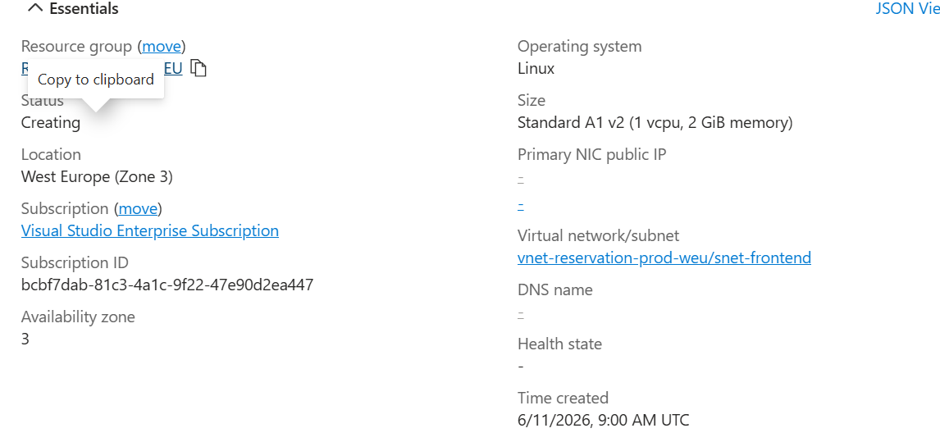

To validate the environment, I set up two test VMs inside the Reservation VNet. These were used to test the NSG rules and confirm that traffic between subnets behaves as expected.
I also set up Azure Bastion for secure access to the VMs. This was needed because I did not want to expose SSH or RDP through public IPs. Bastion allowed me to access the machines securely through the Azure portal while keeping the NSG rules strict.
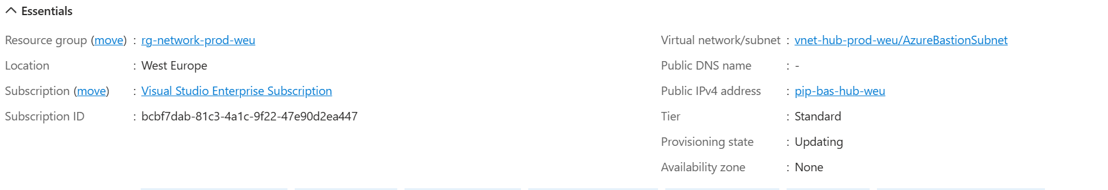

Reflection
I have successfully set up a secure and segmented hub spoke network that follows the principles of no initial trust. Testing is something that has to come at a later stage because there is no clever way to test the segmentation at this point due to the lack of services running on the network I have setup

Requirements:
ID | Requirement
TR-01 | Hub-and-Spoke architecture must be implemented in Azure | Done
TR-02 | Multiple isolated subnets must be created for service separation | Done
TR-03 | Network Security Groups (NSGs) must enforce deny-by-default communication | Done
TR-04 | Only explicitly allowed ports and services may communicate between subnets | Done
TR-05 | Azure Monitor must collect logs and metrics from network resources | Done
TR-06 | NSG Flow Logs must be enabled and stored for analysis | Not possible but i used VNet flow logs
TR-07 | Infrastructure must be deployable using Infrastructure as Code (Bicep) | Done
TR-08 | Management traffic must be separated from application traffic | Done
TR-09 | Unauthorized network attempts must be logged and traceable | Done

Recap of everything setup:
Hub VNet (vnet-hub)
- Subnet VPN
  - VPN Gateway to on-prem GNS3 network
- Subnet Bastion
  - Bastion used for access to VMs
- Peering
  - Connected to all spoke VNets
Spoke VNet - Reservation
- Subnet Frontend (NSG frontend)
- Subnet Backend (NSG backend)
- Subnet Private Endpoint
Spoke VNet - Automation
- Used for Bicep deployment automation
Spoke VNet - Identity
- Can later host Active Directory and DNS
Spoke VNet - IoT
- Reserved for future IoT systems like barrier control systems

